1. Give the name of the Traditional and Digital platform where we can promote TOPS Technologies Pvt. Ltd, and suggest which platform will be better for their marketing activity with a reason?

A. To promote **TOPS Technologies Pvt. Ltd.**, a company involved in IT training, software development, and related services, you can utilize both traditional and digital platforms.

**Traditional Platforms**

**Print Media:**

* Newspapers, magazines, and industry-specific journals.
* Great for reaching local or regional audiences.

**Radio Advertising:**

* Local FM stations.
* Useful for targeting specific geographical locations.

**Television Advertising:**

* Regional or national channels.
* Ideal for mass branding and awareness.

**Billboards and Hoardings**:

* High-traffic areas like city centers and near colleges.
* Effective for creating local awareness.

**Digital Platforms**

**Social Media:**

* Facebook, Instagram, and LinkedIn For targeted ads and engaging with professional and student communities.
* YouTube For tutorials, testimonials, and course demos.

**Search Engines:**

* Google Ads and SEO to target keywords related to IT training and services.

**Email Marketing:**

* Sending newsletters to prospective students and companies.

**Online Education Platforms**:

* Collaborations with Coursera, Udemy, or similar.

2. What are the Marketing activities and their uses?

A. Marketing activities refer to the various strategies and actions taken to promote a product, service, or brand to achieve specific business goals. Below is an overview of key marketing activities and their uses

**1. Market Research**

**Purpose**:

* Understand customer needs, market trends, and competition.

**Uses**:

* Identifying target audiences.
* Developing products or services tailored to customer demand.
* Gauging market potential and setting pricing strategies.

**2. Branding**

**Purpose**:

* Establish a unique identity for the business.

**Uses**:

* Building trust and recognition.
* Differentiating from competitors.
* Creating long-term loyalty.

**3. Advertising**

**Purpose**:

* Promote products or services to a broad audience.

**Uses:**

* Increasing brand awareness.
* Generating leads or sales.
* Reaching specific demographics via channels like TV, print, digital, and social media.

**4. Social Media Marketing**

**Purpose**:

* Use social platforms to connect with audiences.

**Uses**:

* Driving engagement through likes, shares, and comments.
* Promoting brand values and updates.
* Advertising products or services to targeted demographics.

3. What is Traffic?

A. In the context of marketing and business, **traffic** refers to the flow of visitors to a specific platform, typically a website, online store, or social media page. It measures the number of people who interact with a digital property, providing insights into visibility, engagement, and potential for conversions.

4. Things we should see while choosing a domain name for a company.

A. Choosing the right domain name for a company is a critical decision that can impact your brand identity, online visibility, and overall success. Here are the key factors to consider

**1. Keep it Simple and Short**

**Why?**

* Easy-to-remember domain names are more likely to attract and retain visitors.

**Tip**:

* Avoid long, complex words or phrases.

**Example**:

* Prefer **tops-int.com** over **topstechnologiescompanytrainingservices.com**.

**2. Relevance to Your Business**

* Ensure the domain name reflects your company name, services, or industry.
* Helps in building trust and improving branding.

**Example**:

* If your company provides IT training, a domain like **topstechnologies.com** is relevant.

**3. Choose the Right Domain Extension**

* **.com**: Best for global businesses.
* **.in**: Suitable for Indian businesses.
* **.edu**: Ideal for educational institutions.
* **.tech**: Great for technology-focused businesses.

**4. Check Domain Availability**

* Use domain registrars like **GoDaddy**, **Namecheap**, or **Google Domains** to check if the desired name is available.
* If unavailable, look for close alternatives.

5. What is the difference between a Landing page and a Home page?

A. A **landing page** and a **homepage** serve distinct purposes in a website's structure and functionality. Here’s a detailed comparison:

**1. Purpose**

**Landing Page**:

* Designed for a **specific goal or campaign** (e.g., lead generation, sales, or event registration).
* Focuses on a single **call-to-action (CTA)**, such as "Sign Up," "Download," or "Buy Now."
* Typically used in marketing campaigns, such as Google Ads or social media promotions.

**Example**:

* A page offering a free eBook in exchange for email addresses.

**Homepage**:

* Acts as the **main entry point** to a website.
* Provides an **overview of the brand, products, and services**.
* Includes links to various sections of the site (e.g., About, Services, Blog, Contact).

**Example**:

* The front page of **amazon.com** showcasing categories, offers, and promotions.

**2. Structure**

**Landing Page**:

* Minimal distractions with a clear focus on achieving one action.
* Often lacks navigation menus or links to other parts of the site to keep users focused.
* May include persuasive elements like testimonials, benefits, or limited-time offers.

**Homepage**:

* Contains multiple links, menus, and sections to guide visitors through the site.
* Showcases the overall value proposition of the brand.
* Encourages exploration rather than immediate action.

**3. Target Audience**

**Landing Page**:

* Targets a **specific audience** or user segment.
* Often customized based on the marketing channel or campaign that directed the visitor to it.

**Homepage**:

* Caters to a **broad audience**, including new and returning visitors.
* Acts as a starting point for users to navigate the website.

6. List out some call-to-actions we use, on an e-commerce website.

A. Here’s a list of common call-to-actions (CTAs) used on e-commerce websites:

**For Product Discovery:**

**Shop Now**

**View Collection**

**Explore More**

**Discover Deals**

**Browse Categories**

**For Purchases:**

**Add to Cart**

**Buy Now**

**Proceed to Checkout**

**Place Order**

**Reserve Now**

**For Promotions and Discounts:**

**Get the Offer**

**Apply Coupon**

**Claim Your Discount**

**Limited Time Offer - Shop Now!**

**Redeem Points**

**For Engagement:**

**Sign Up for Deals**

**Join Loyalty Program**

**Subscribe & Save**

**Notify Me When Available**

**Write a Review**

**For Support:**

**Contact Us**

**Live Chat**

**Track Your Order**

**View Return Policy**

**Ask a Question**

7**.** What is the meaning of keywords and what add-ons we can use with them?

A. Keywords are specific words or phrases that define the main topics of a webpage or piece of content. They are the terms users enter into search engines when looking for information, products, or services. In digital marketing and SEO, keywords help connect your website content with relevant search queries to drive organic traffic.

### ****Add-ons You Can Use with Keywords****

#### ****1. Long-Tail Keywords****

* Phrases that are more specific and usually longer than primary keywords.

**Example:**

* Instead of "shoes," use "comfortable running shoes for women."

**Purpose:**

* Helps target niche audiences with higher intent.

### 2.Short-Tail Keywords

A **short-tail keyword** is a broad and general keyword that typically consists of one to two words. These keywords have a high search volume but are also highly competitive and less specific.

**Examples:**

* "Shoes"
* Laptops"

8. Please write some of the major Algorithm updates and their effect on Google rankings.

A. Here’s a list of major Google algorithm updates and their effects on rankings:

**1. Panda Update(2011):**

* Implemented to prioritize high-quality content over low-quality or spam content.
* Many websites that published unique, thorough and useful content saw a boost to their SERP ranking.

**2. penguin Update(2012):**

* Focused on backlinks- links to sites from sources outside one’s own websites.
* This update made manipulative backlinking practices, such as paid backlinks from low-quality sites, a negative ranking factor.

**3. Exact match Domain Update(2012):**

* Prior to implementation, low-quality or spam websites could easily rank at the top of the SERP if their domain names matched popular keywords phrases.
* This update prioritized content quality over how closely a websites domain name matched a particular keyword phrase.

**4. Venice Update(2012):**

* Improved googles ability to identify searcher intent for localize search results, such as webpages for local businesses.
* This change let small businesses complete with large organizations for broad keywords.

**5. Pirate Update(2012):**

* Originally known as the Digital millennium copyright Act update, it placed a negative ranking value on websites that received many DMCA takedown requests and incentivized website owners to adhere to copyright laws and publish original content.

**6. Hummingbird Update(2013):**

* Enhanced google’s ability to process conversational language.
* This update improved search result accuracy, especially for long- tail keyword phrases.

**7. Pigeon Update(2014):**

* Improved location- based searches to offer results closer to searchers locations.
* It let users see top- ranking businesses in their neighborhoods as opposed to those of their city or region.

**8. HTTPS/SSL Update(2014):**

* Implemented the HTTPS/SSL update to encourage website owners to secure their sites with HTTPS-a file sharing protocol that users the security sockets layer (SSL) protocol.
* SSL encrypts information that flows between web servers and clients.

**9. Mobile Update(2015):**

* Made mobile- friendly websites layouts a positive ranking factor.
* Pages that didn’t require mobile users to zoom in or scroll horizontally saw a ranking boost for mobile searchers.

**10. RankBrain Update(2015):**

* Added a machine learning component to googles search algoritham to identify searchers intent more accurately.
* This update let the algorithm learn from previous searchers and offer results that past users found most relevant.

**11. Mobile speed Update(2018):**

* Before 2018, website speed was a ranking factor for desktop searches , but not for mobile.
* The mobile speed update implemented site speed as a ranking factor for mobile searchers.

**12. Medic Upade(2018):**

* Made expertise and topical authority a strong ranking factor for health, wellness and personal finances sites.
* Many sites that had non- experts share advice on these topics dropped in SERP ranking following this update.

**13. Bert Update(2019):**

* Added natural language processing capabilities to help the algorithm understand complex language in search queries.
* Unlike rankbrain , BERT doesn’t rely on past search data to interpret intent.

**14. Page Experience Update(2021):**

* Added UX as a ranking factor to googles algorithm .
* The update incentivized pages to have shorter load times and offer smooth navigation across desktop and mobile devices.

**15. Helpful content Update(2022):**

* Implemented to further prioritize high-quality content that is more likely to meet readers needs.
* It penalizes websites that produce low-quality content or rely heavily on automation tools to create content.

9. What is the Crawling and Indexing process and who performs it?

### A. ****Crawling and Indexing Process****

#### ****1. Crawling****

**Definition**:

Crawling is the process where search engine bots (often called "crawlers" or "spiders") scan websites to discover new and updated content.

**Who Performs It?**

Search engine bots such as:

* **Googlebot** (Google)
* **Bingbot** (Bing)
* **Yandex Bot** (Yandex)
* **Baidu Spider** (Baidu)

**How It Works**:

* The crawler starts with a list of known URLs, known as the **seed list**.
* It visits these pages and follows internal and external links to discover more URLs.
* The crawler collects information about the content, metadata, and structure of the pages.

**Challenges in Crawling**:

**Blocked Pages**:

* Pages restricted by robots.txt or meta tags.

**Dynamic Content**:

* Pages generated via JavaScript can be harder to crawl.

**Deep Pages**:

* Pages buried deep in the site hierarchy may not be discovered easily.

#### ****2. Indexing****

**Definition**:

* Indexing is the process where the crawled data is analyzed, organized, and stored in the search engine's database (index) to make it accessible for search queries.

**Who Performs It?**

* Search engine algorithms process the data collected by their crawlers to add it to the index.

**How It Works**:

* The crawled content is processed to extract information about its relevance and topic.
* Key factors like keywords, meta tags, headings, and structured data are analyzed.
* The page is stored in the index if it’s deemed valuable and adheres to the search engine's guidelines.

**Challenges in Indexing**:

**Duplicate Content:**

* Can result in only one version being indexed.

**Poor-Quality Content:**

* May be excluded from the index.

**Non-Indexable Pages:**

* Pages blocked by noindex tags or those with insufficient content won't be indexed.

10. Difference between Organic and Inorganic results.

A. The difference between **organic** and **inorganic** results primarily lies in how they are generated and their purpose within search engine results pages (SERPs). Here's a breakdown

**Organic Results**

**Definition**:

* These are search results that appear naturally on a search engine results page (e.g., Google) because they are deemed most relevant to the user's query by the search engine's algorithm.

**Characteristics**:

**Unpaid**:

* Websites or pages do not pay to appear in these positions.

**SEO-Driven**:

* The ranking is based on factors like keywords, content quality, backlinks, page speed, and user experience.

**Trust Factor**:

* Often perceived as more trustworthy because they are not explicitly labeled as ads.

**Examples**:

* Blog posts, product pages, news articles, or videos that match the user's query naturally.

**Inorganic Results**

**Definition**:

* These are search results that appear because someone has paid for them, usually through advertising platforms like Google Ads.

**Characteristics**:

**Paid**:

* Businesses pay to have their pages displayed for specific keywords.

**Identified as Ads**:

* Usually marked with labels like "Ad" or "Sponsored" to differentiate them from organic results.

**Immediate Visibility**:

* Provide quick visibility but disappear when the payment stops.

**Examples**:

* Pay-per-click (PPC) ads, banner ads, and promoted search listings.

11. Create a blog for the latest SEO trends in the market using any blogging site.

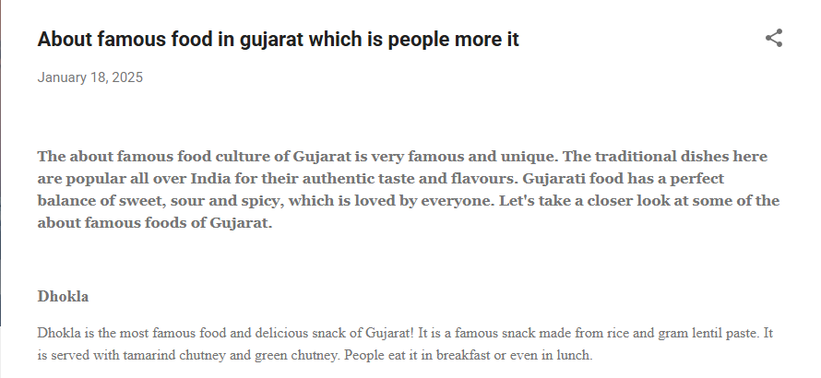

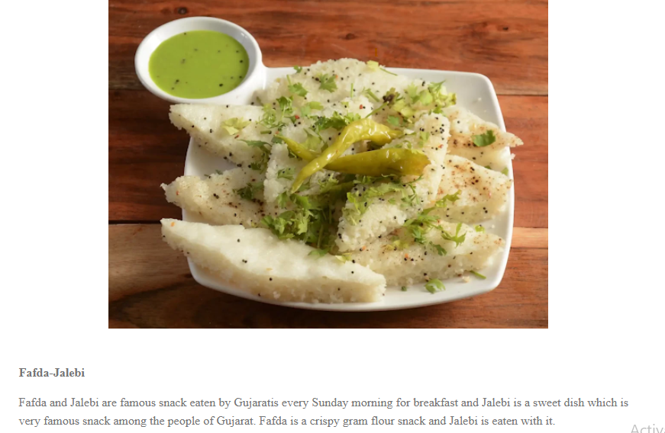

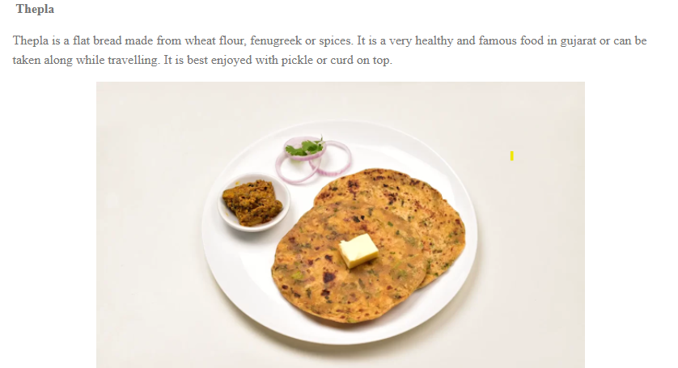

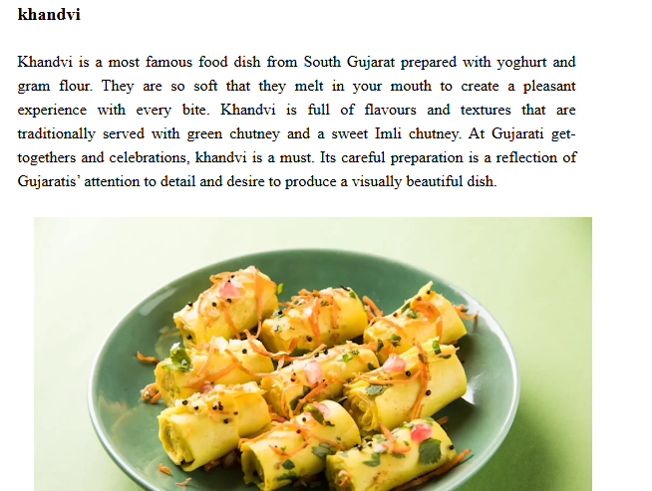

12. Create a website for the business using www.blogger.com / Wordpress.com / Google Sites.

